Technical Documentation: AI Recommendation & Reasoning Engine

1. Architectural Overview
The AI subsystem of JobIntel is designed as a decoupled, asynchronous microservice built using Python and FastAPI. It operates as a continuous evaluation pipeline that eliminates the constraints of traditional keyword-matching Applicant Tracking Systems (ATS). Instead of performing simple string lookups, the subsystem unifies exact programmatic filters, high-dimensional semantic vector mathematics, and contextual Large Language Model (LLM) reasoning into a single processing boundary.
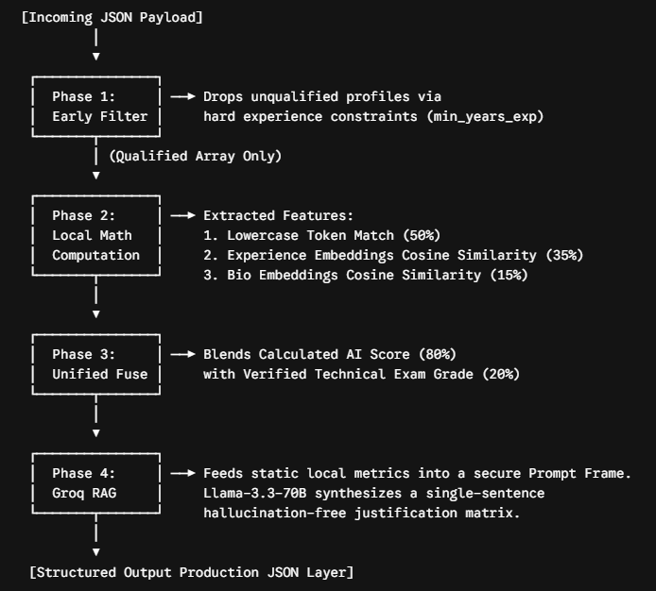

2. Mathematical Scoring Model & Data Fusion
The sorting logic completely isolates text processing variables, ensuring empirical fairness. The final ranking of a candidate is determined through a two-stage mathematical fusion.
2.1 The Internal AI Match Weight Matrix
The text metadata of the candidate is divided into three distinct functional features, calculated locally via Python computing blocks:
- Canonical Skill Overlap ($50\%$ weight): The required job skills and candidate skills are stripped of structural irregularities, converted to uniform lowercase tokens, and processed via set intersection logic.
- Experience Semantic Proximity ($35\%$ weight): The full text of experience_details is transformed into numerical matrices and compared against the target job description text.
- Bio Semantic Proximity ($15\%$ weight): The candidate's summary biography text is mapped against the job description to calculate soft semantic alignment.
$$\text{AI\_Match\_Total} = (\text{Skill\_Score} \times 0.50) + (\text{Experience\_Score} \times 0.35) + (\text{Bio\_Score} \times 0.15)$$
2.2 The Empirical Validation Fusion
To prevent candidates from fabricating claims on their resumes, the system integrates a live technical examination gate handled by the backend. The mathematical score computed above is fused with the actual exam grade using an $80/20$ ratio:
$$\text{Final\_Score} = (\text{AI\_Match\_Total} \times 0.80) + (\text{Test\_Value} \times 0.20)$$

3. Technology Stack & Machine Learning Models
- Core Runtime Environment: Python 3.10+ and FastAPI.
- Semantic Vectorization Model: sentence-transformers/all-MiniLM-L6-v2. This local model converts raw text into dynamic 384-dimensional dense vector embeddings, allowing the system to understand that a phrase like "Built backend endpoints" maps semantically to "Developed server-side APIs" even with zero exact keyword overlaps.
- Mathematical Assessment Packages: scikit-learn (specifically utilizing cosine_similarity spatial calculations), pandas for structural tabular mutations, and numpy for localized matrix operations.
- Generative Synthesis & Language Framework: Groq Cloud API running the advanced Open-Source llama-3.3-70b-versatile foundation framework.

4. The Zero-Hallucination RAG Integration Strategy
A critical innovation within JobIntel's AI layer is the execution of a Strict Contextual Retrieval-Augmented Generation (RAG) Policy. Out-of-the-box LLMs are highly volatile and frequently fabricate non-existent qualifications (hallucinations) during candidate profiles evaluations.
To eliminate this vulnerability, the system strictly separates mathematical calculation from language generation:
- The Python service performs all data lookups, calculating the exact Matched Skills, Missing Skills, Cosine Embeddings Score, and extracts the Exam Grade locally.
- These static parameters are injected into an unyielding, structured system prompt frame.
- The external Large Language Model is systematically blocked from choosing weights or inventing features. It acts strictly as an objective Linguistic Reasoner Core, converting our computed numerical facts into a highly structured, single-sentence human-readable report string (reason).

5. System Data Exchange Contract (API Specifications)
The microservice exposes a secure REST gateway handling structured JSON payload interactions.

5.1 Inbound Data Contract (POST /api/recommend)
The API handles nested object arrays passed securely from the server framework:

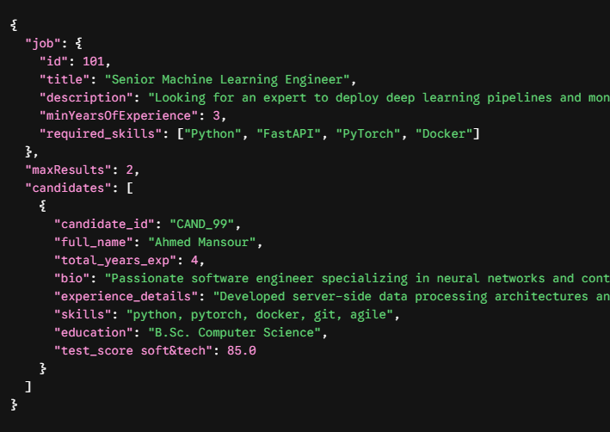

5.2 Outbound Production Contract (Response Schema)
The microservice returns a structured, sorted array of recommendations containing the calculated scores and localized RAG feedback text strings:

